Decision Tree Regressor - Complete Learning Handbook

Definition
Decision Tree Regressor is a supervised machine learning algorithm that predicts continuous values by recursively splitting data into smaller groups based on decision rules.

Category
Machine Learning > Supervised Learning > Regression

Why Use It?
Used when relationships are non-linear and cannot be represented by a straight line.

Key Components
Root Node, Internal Node, Split, Branch, Leaf Node

Use Cases
House Price Prediction, Revenue Forecasting, Demand Forecasting, Energy Consumption Prediction

Tree Structure
Root Node
|
Feature < Value?
|
Yes No
| |
Leaf A Leaf B

Formula Naming
1. MSE (Mean Squared Error)
MSE = Average of Squared Errors
2. Variance
Measures spread of target values.
3. Variance Reduction
Used to select best split.
4. Prediction
Prediction = Mean value of records in leaf node.

Sample Dataset
House Size | Price
1 | 10
2 | 12
3 | 25
4 | 28
5 | 40
6 | 45

Manual Split Calculation
Assume split at House Size <= 3
Left Group Prices:
10,12,25
Right Group Prices:
28,40,45
Tree evaluates which split reduces variance most.
Best variance reduction becomes selected split.

Prediction Logic
New Record:
House Size = 2.5
Rule:
House Size <= 3
Falls into Left Leaf
Prediction = Mean(10,12,25)
= 15.67

Graph Visualization
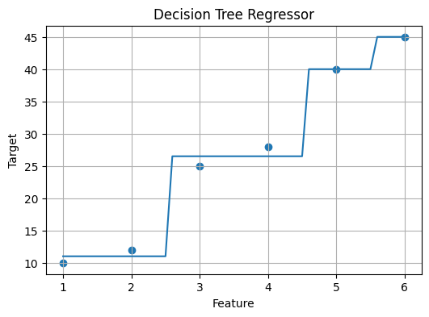

Python Implementation - Manual Understanding
# Concept
1. Select feature
2. Try multiple split points
3. Calculate variance reduction
4. Choose best split
5. Repeat recursively
6. Leaf node stores average target value

Python Implementation - sklearn
from sklearn.tree import DecisionTreeRegressor
X=[[1],[2],[3],[4],[5],[6]]
y=[10,12,25,28,40,45]
model=DecisionTreeRegressor(max_depth=2)
model.fit(X,y)
prediction=model.predict([[3.5]])
print(prediction)

Important Hyperparameters
max_depth
min_samples_split
min_samples_leaf
max_features
criterion

Advantages
Handles non-linear data
Easy to understand
No feature scaling required

Limitations
Can overfit
Sensitive to small data changes
Lower accuracy than ensembles

Interview Questions
1. What is Decision Tree Regressor?
2. What is a leaf node?
3. How does a tree choose a split?
4. What is variance reduction?
5. Why does overfitting happen?
6. Difference between Linear Regression and Decision Tree Regressor?

Project Flow
Raw Data
↓
Feature Engineering
↓
Decision Tree Regressor
↓
Prediction
↓
API / Dashboard

